Look out for your Census - Have your say! 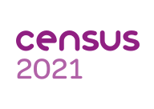

All households in Kent will very soon be receiving a card in the post from Census 2021 telling them that the census is about to take place, then at the beginning of March you will receive a letter which will mean that you can start to fill in the census. The letter will give you an access code for you to fill the questionnaire on-line, by far the quickest and easiest way to complete the census. However if you need extra help for any reason at all or access to the internet is difficult, please call the freephone number given on the letter, where someone will be there to listen and support you.
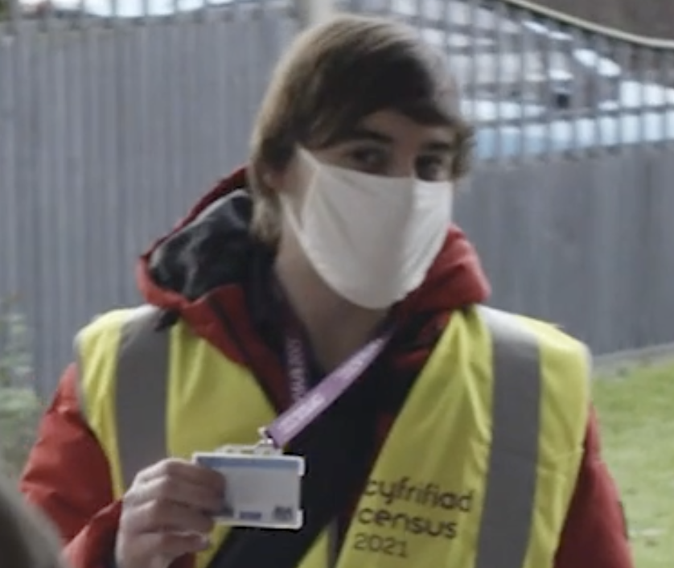
In organising the teams, our main concern is the safety of the public and our team. We want everyone to be safely counted during the census. To do this, we’re making sure that our plans are always in line with the latest government safety guidelines. As you can imagine, that means that they have been under constant review and been regularly tweaked. They will be wearing Personal Protective Equipment and will never need to enter your home.

At the end of last year, some people asked me whether the census would go ahead and why now? We are all geared up and, equally importantly, the information it provides is incredibly important. The Office for National Statistics has used past census information to help us understand how the coronavirus (COVID-19) pandemic has affected people in different ways and respond accordingly. Census 2021 will give us fresh information to improve our understanding of the pandemic. The results will help to make sure that the services you use meet the needs of our changing society. This could include hospitals, schools, community services and transport
For more information please go to https://census.gov.uk/

